ETL Issues :

Issue 1: Count Drops: Noticed count drop in d_application_pg_data_privacy_c view:

SELECT a12.application_pg_data_privacy_c_key,a13.row_key,count(1) as cnt

FROM ldb.f_rita_application_c_fact a11

LEFT JOIN ldb.d_rita_application_c a12 ON a11.rita_application_c_key=a12.row_key

LEFT JOIN ldb.d_application_pg_data_privacy_c a13 ON a12.application_pg_data_privacy_c_key=a13.row_key

group by 1,2;

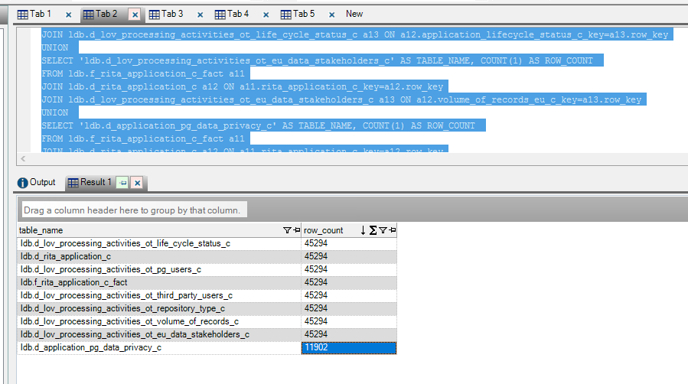

Issue 2: Data Stakeholders for EU: limited Data in cube.

SELECT a12.volume_of_records_eu_c_key,a13.row_key,count(1) as cnt

FROM ldb.f_rita_application_c_fact a11

LEFT JOIN ldb.d_rita_application_c a12 ON a11.rita_application_c_key=a12.row_key

LEFT JOIN ldb.d_lov_processing_activities_ot_eu_data_stakeholders_c a13 ON a12.volume_of_records_eu_c_key=a13.row_key

group by 1,2;

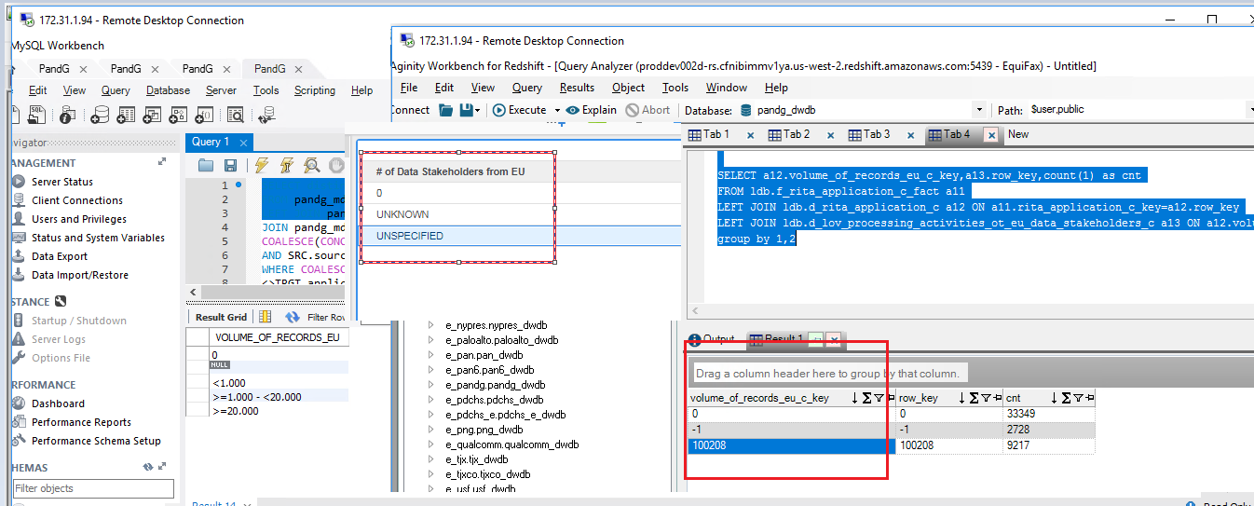

Issue 3: Count of Data Asset Names are not matched:

SELECT count(

distinct SRC.SHORT_NAME)

FROM pandg_mdsdb.pg_mega_pgb_application_rita_final SRC

LEFT JOIN pandg_mdwdb.d_rita_application_c TRGT ON SRC.NAME=TRGT.row_id AND SRC.sourceinstance=TRGT.source_id

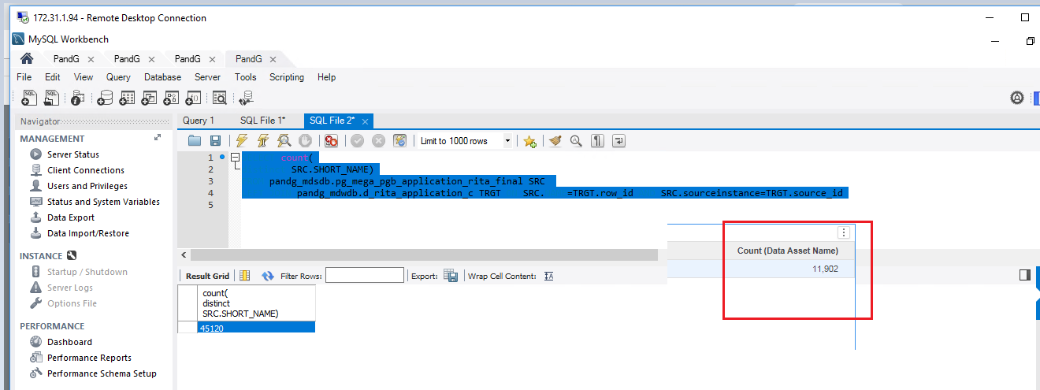

Issue 4: GDPR Sensitivity is Null:

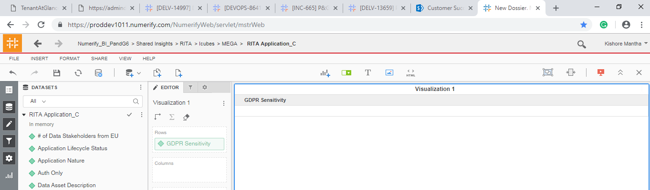

Issue 5: ‘Grace Period Start Date’ is not populated:

For the Below conditions are met the last refresh data is displaying:

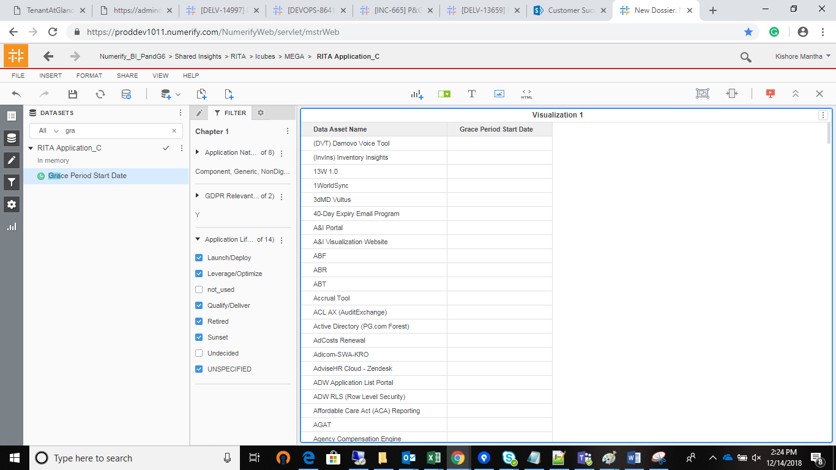

Issue 6:’Pii Data Handled for Specified BP’ is displaying only UNSPECIFIED.

SELECT distinct SRC1.pii_handled_for_specific_bp,count(1) as cnt

from pandg_mdsdb.pg_mega_pgb_application_rita_final SRC

LEFT JOIN pandg_mdsdb.pg_mega_pgv_app_responsible_org_person_final SRC1 ON SRC.NAME=SRC1.app_hexid AND SRC.sourceinstance=SRC1.sourceinstance

LEFT JOIN pandg_mdwdb.d_rita_application_c TRGT ON SRC.Name=TRGT.row_id AND SRC.sourceinstance=TRGT.source_id

group by 1;

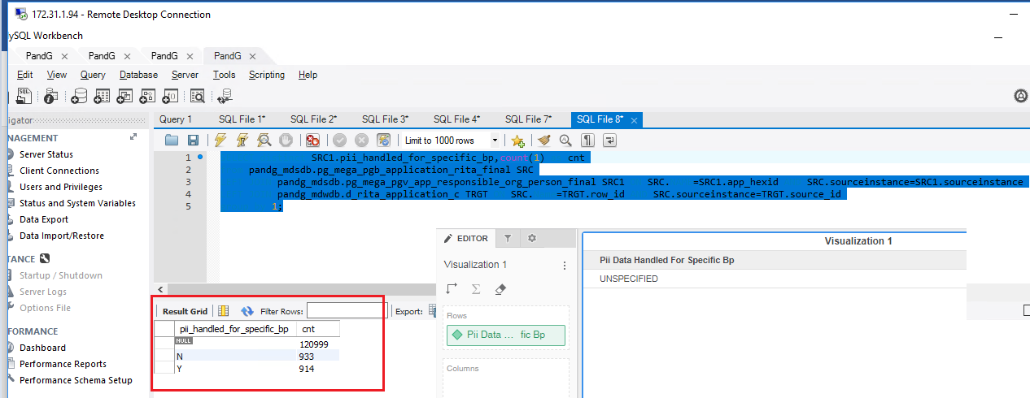

Issue 7: ‘Volume of Records-All Countries’ attribute is not displaying expected Data :

Data is available in Dimension, Data is not displayed when joined with Fact.

ETL issue:

SELECT distinct SRC.VOLUME_OF_RECORDS_ALL,LKP.dimension_code,LKP.dimension_class,LKP.dimension_name,

count(1) as cnt

FROM pandg_mdsdb.pg_mega_pgb_application_rita_final SRC

LEFT JOIN pandg_mdwdb.d_rita_application_c TRGT ON SRC.NAME=TRGT.row_id AND SRC.sourceinstance=TRGT.source_id

LEFT JOIN pandg_mdwdb.d_lov LKP ON

COALESCE(CONCAT('OT_VOLUME_OF_RECORDS_C~PROCESSING_ACTIVITIES',upper(SRC.VOLUME_OF_RECORDS_ALL)),'UNSPECIFIED')=LKP.row_id

AND SRC.sourceinstance=LKP.source_id

group by 1;

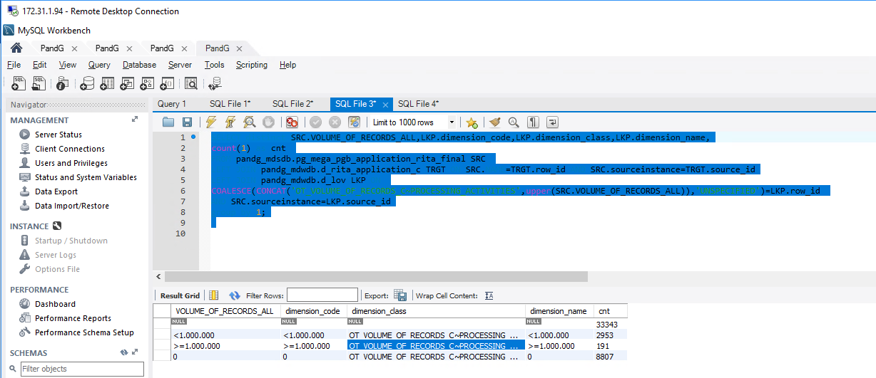

SELECT a12.application_volume_of_records_all_c_key,a13.row_key,count(1) as cnt

FROM pandg_mdwdb.f_rita_application_c a11

LEFT JOIN pandg_mdwdb.d_rita_application_c a12 ON a11.rita_application_c_key=a12.row_key

LEFT JOIN pandg_mdwdb.d_lov a13 ON a12.application_volume_of_records_all_c_key=a13.row_key

group by 1,2;

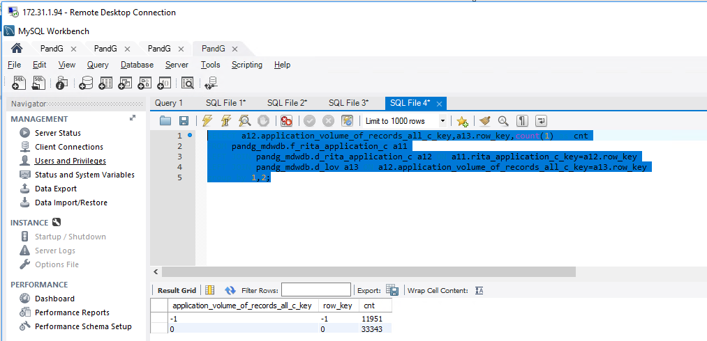

MSTR Issues :

Issue 1: Mega ID is NULL / No Need to get it in Cube : Need to Use ‘Mega Hex’ Attribute.

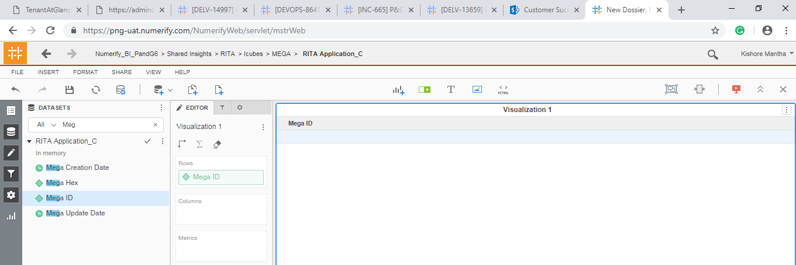

Issue 2:Mega Hex is having multiple forms :

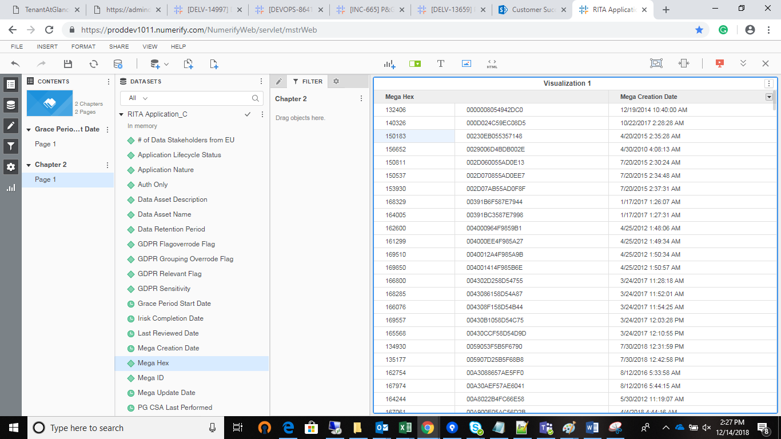

Metric validation :

Deviation from the Redshift :

Select b.data_asset_name,a.percent_complete_c,a.percent_incomplete_c

FROM ldb.f_rita_application_c_fact a

JOIN ldb.d_rita_application_c b ON a.rita_application_c_key=b.row_key

